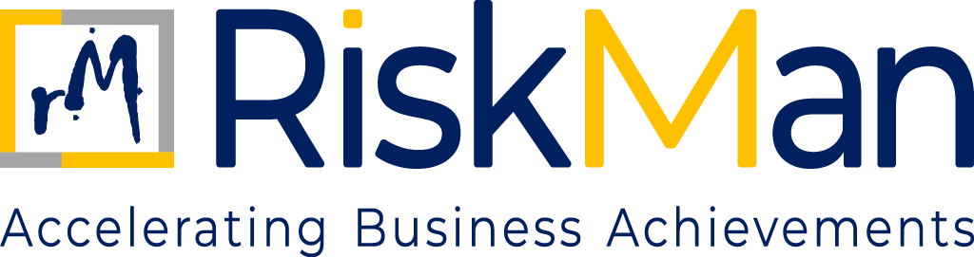
HUMAN RIGHTS POLICY
TABLE OF CONTENTS
Human Rights Policy

- Objective…………………………………………………………………………………………..……………………………………..3
- Scope…………………………………………………………………………………………………..……………………………….....3
- Policy…………………..………………………………………………………………………………..……..………………………….3
- Communication of Policies……………………………………………………………………..…………………………….....4
- Risk Assessment and Due Diligence…………………………………………………………..……………………………..5
- Grievance Redressal Mechanism………………………………………………………………..…………………………….5

HUMAN RIGHTS POLICY
- OBJECTIVE

RiskMan is committed to reinforcing and upholding human rights through its Human Rights Policy. We have zero tolerance against human rights violations, and we do our best to ensure that no abuse of human rights happens within any part of our business and encourage suppliers to adhere to the same.

We also encourage our employees, partners, and community to speak up, without any fear of retaliation about any concerns they may have or any form of harassment they face at the workplace.

- SCOPE

This policy applies to all individuals and entities associated with RiskMan Consulting LLP. It covers all employees, including those who are permanent, contractual, or interns, as well as partners, consultants, and associates who are professionally engaged with the Firm. Additionally, the policy extends to clients, suppliers, vendors, and any other third-party stakeholders who interact with or are connected to the operations and business activities of RiskMan in any capacity.

- POLICY

- Equal Opportunity & Non-Discrimination
RiskMan Consulting is committed to fostering a work environment that is inclusive, respectful, and free from all forms of discrimination. Our Equal Opportunity Policy ensures that employment decisions are made solely based on merit and business requirements, without bias or prejudice. Discrimination on the grounds of race, religion, color, gender, gender identity, national origin, physical or mental disability, medical condition, marital status, age, sexual orientation, pregnancy, or any other characteristic protected under applicable laws is strictly prohibited.

- Gender Pay Equality
RiskMan Consulting upholds the principle of equitable compensation. We are committed to ensuring that all employees receive equal pay for equal work, regardless of gender or any other protected characteristic. Compensation decisions are based on performance, roles & responsibilities, and business outcomes, not on personal identity.

- Harassment-Free Workplace
RiskMan Consulting maintains a zero-tolerance policy towards all forms of harassment, including sexual, verbal, physical, and psychological abuse. Through our Code of Conduct and Prevention of Sexual Harassment (POSH) Policy, we are committed to providing a safe, inclusive, and respectful workplace.

- Workplace Diversity and Inclusion
We actively promote diversity, equity, and inclusion at all organizational levels. RiskMan Consulting strives to eliminate stereotypes in its language, policies, and practices, and fosters a culture where differences are embraced and respected. Inclusive language is used across all official documentation to avoid bias related to gender, age, race, or ability.

- Freedom of Association and Collective Bargaining
RiskMan Consulting respects every employee’s right to freely associate, form or join trade unions, and engage in collective bargaining. We also provide effective grievance redressal mechanisms to address employee concerns in a timely and fair manner.

- Prohibition of Child and Forced Labour
We have a strict policy against child labour and any form of forced or involuntary labour, including bonded labour, servitude, and human trafficking. This principle is embedded in our Code of Conduct and applies equally to all business partners and supply chain stakeholders.

- Modern Slavery
RiskMan Consulting adheres to global human rights frameworks including the UN Declaration of Human Rights, the Modern Slavery Act, 2015 (UK), and other relevant international conventions. We have a zero-tolerance approach to all forms of modern slavery and ensure fair, ethical, and dignified treatment of every individual associated with our operations.

- Human Dignity
We uphold the inherent dignity of every individual and are committed to maintaining a workplace where everyone is treated with respect. Any form of abusive behaviour, humiliation, or harassment is considered a serious violation of our Code of Conduct. Employees are encouraged to raise concerns through confidential and well-defined channels, with assurance of non-retaliation.

- Occupational Health and Safety
RiskMan Consulting is dedicated to safeguarding the health and safety of all employees and contractors. We implement comprehensive workplace safety protocols and regularly monitor compliance. Our health and safety measures also include provisions for women’s safety, emergency response readiness, and accessibility support for persons with disabilities.

- Data Privacy
We prioritize the privacy and protection of personal data belonging to employees, clients, and stakeholders. RiskMan Consulting follows robust data governance practices in line with global privacy standards. We collect, process, and store data responsibly and do not share personal information without explicit consent, unless required by law.

- Working Conditions
RiskMan Consulting ensures compliance with all applicable labour laws and industry standards relating to working conditions, including working hours, benefits, and employee rights. We aim to create a positive and productive work environment for all employees.

- Living Wages
We are committed to providing fair and adequate compensation that meets or exceeds the legal minimum wage standards. RiskMan Consulting ensures that all employees are paid a living wage sufficient to maintain a decent standard of living for themselves and their dependents.

- COMMUNICATION OF POLICIES

RiskMan communicates transparently all necessary and relevant information with all the relevant stakeholders regarding policies and procedures related to human rights. We ensure that all the employees are made aware of these policies and guidelines when they join the organisation. During an employee’s service with the organisation, they are sent periodic reminders on the same and informed in case of any updates in this Policy. All RiskMan policies are also uploaded on our internal HRMS portal (Zoho People), which is accessible to all employees.

- RISK ASSESSMENT AND DUE DILIGENCE

RiskMan considers the dangers to human rights that may arise directly or indirectly from corporate operations. RiskMan is dedicated to performing regular due diligence and human rights risk assessments throughout our activities. This entails determining the existing and possible effects on human rights, evaluating how serious they are, and taking the necessary precautions to lessen or avoid them.

- GRIEVANCE REDRESSAL MECHANISM

RiskMan has put a grievance redressal mechanism to have a corrective action approach for any conflict or complaint related to human rights.
To ensure a respectful and inclusive workplace that upholds human dignity and human rights, RiskMan Consulting LLP has established the following grievance redressal mechanism:
- Reporting
Any employee, intern, or stakeholder may report a human rights-related concern (e.g., discrimination, harassment, unfair treatment) in writing at grievance@riskman.in
- Confidentiality
All complaints will be treated with strict confidentiality and sensitivity.
- Initial Review
The Grievance Officer will acknowledge the complaint within 3 working days and initiate a preliminary review.
- Resolution Timeline
Efforts will be made to resolve the grievance within 15 working days through fair investigation and dialogue.
- Escalation
If the issue remains unresolved, it may be escalated to the Managing Partner(s) for final review.
- Protection Against Retaliation
Retaliation against any complainant is strictly prohibited and may lead to disciplinary action.

